MG Reporting Cheat Sheet
This guide is a quick handy resource for reminders on how to do basic functions in the TEMG Reporting System. For detailed instructions, see the database packet with screen shots.
  - Reporting Deadline:
  - All service activities and continued education should be entered by the second Friday in November each year. Please guestimate hours that will be achieved through the months of November and December and include those with your report.
Register: First time users only
-https://temg.tennessee.edu
-Click Register
-Enter Email
-Create a Password
-Click Register
-This will automatically take you to the edit profile page where you should fill out information as fully as possible and click “Update Profile.”

Sign-In: All other times to access database
-https://temg.tennessee.edu
-Click Sign In
-Enter e-mail
-Enter Password
-Click Log In

View Volunteer Dashboard:
-After you sign in, the page will open to your Volunteer Dashboard. This is a quick summary of your hour entries for the year-to-date.
-To access this page at any time while logged in, simply click the Home tab at the top of the gray menu bar and select Year-To-Date Dashboard.

Home Tab Navigation:
-click the Home tab in the gray menu bar to reveal sub-tabs
- Year-to-Date Dashboard (Home Volunteer Dashboard)-quick summary of all of your personal reports for the year
- Volunteer Activity Reports- Search your archived reports from years’ past
-County Dashboard- Access the County Roster, and County Reports

CEU Tab Navigation: Report Education Hours
-Click CEU icon at the top of the menu bar
-Click Log CEU Hours
-Enter Program Name ex: Monthly MG Meeting
-Enter Description ex: Carol Reese Native Plants
-Select a Category from the drop down box. Doesn’t have to be exact.
-Enter Hours spent learning
-Select Program Date
-Click Submit
*If the hours were successfully submitted, a message saying “CEU Report Saved” will appear on screen in green.

Project Tab Navigation: Report Service Hours
-Click Project icon at the top menu bar
-click Log Project Hours
-select project from drop down list
-click the green magnifying glass to open project
-enter Hours, Miles, Project Date
-click Submit
*If the hours were successfully submitted, a message saying “Report saved for the project titled: ____________” will appear on your screen in green!

Update Profile Information:
-Click the Profile Icon on the top right of the menu bar
Username:
-click the blue text “Change Email”
-make changes
-click Reset
Password:
-click the blue text “Change”
-make changes
-click Change password
Profile:
-click the blue text “My Profile”
-make changes
-click Save Profile Information
Photo:
-click the blue text “Manage Profile Image”
-click Choose File
-select picture from your saved pictures & click open
-click Save Image

Forgot Password:
-On Log-in page, enter e-mail but don’t put in a password
-Click Submit
-A page will appear with options on how to proceed
-Select “Forgot your password?”
-A box will appear, Enter your email
-Click Submit
-An e-mail will be sent to you with your password

Mobile Reporting
1.
Register: First time users only
-www.temg.tennessee.edu (1)
-Click Register (2)
-Enter Email
-Create a Password
-Click Register

Sign-In:
-www.temg.tennessee.edu
-Click Sign In (3)
-Enter e-mail
-Enter Password
-Click Log In
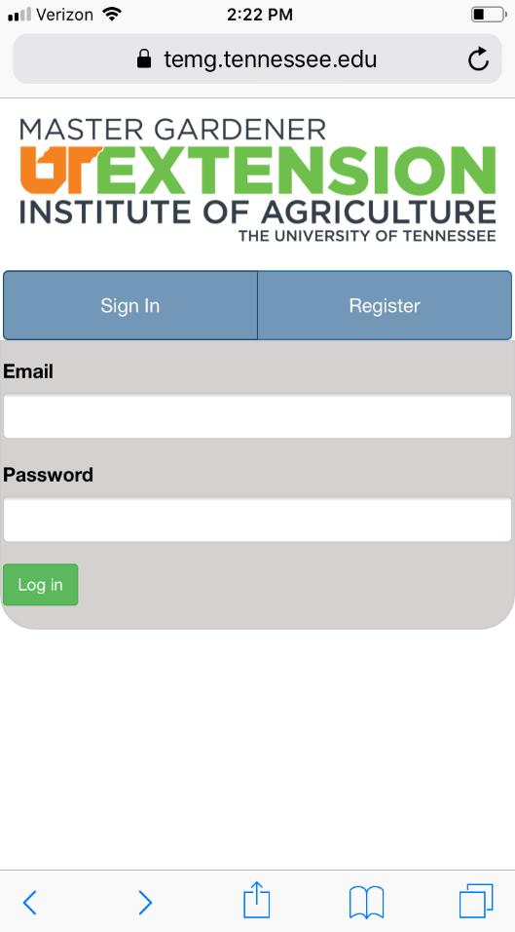
3.
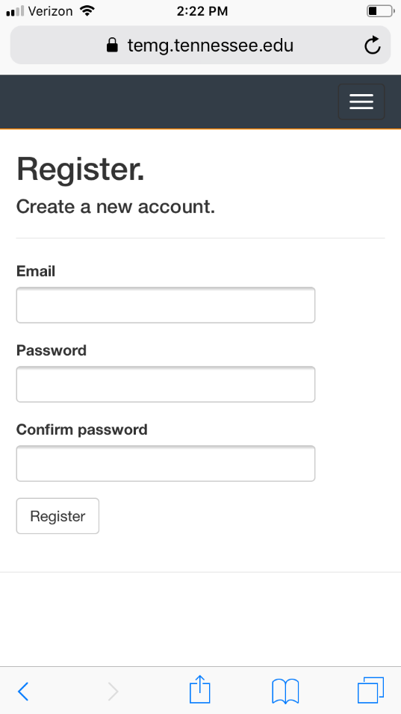
2.

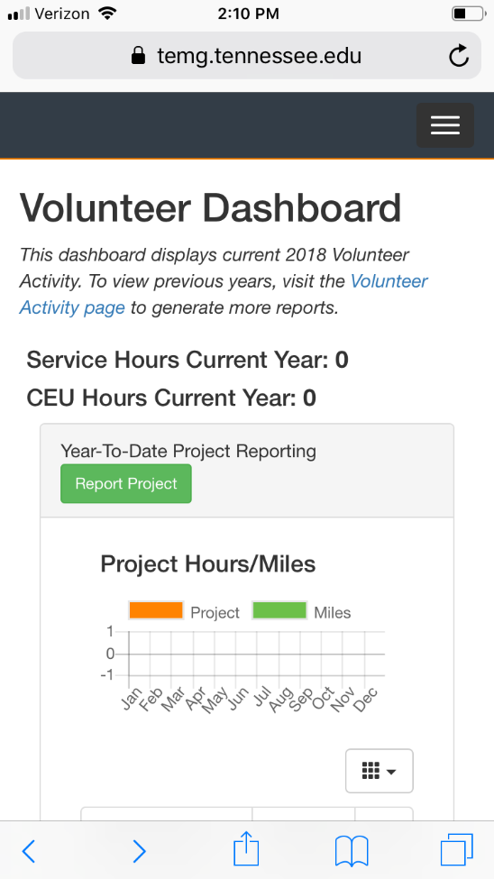
Once you have registered and signed in, you are
4.
Ready!
This is the view of your volunteer dashboard.
To access options, click on this box (4).

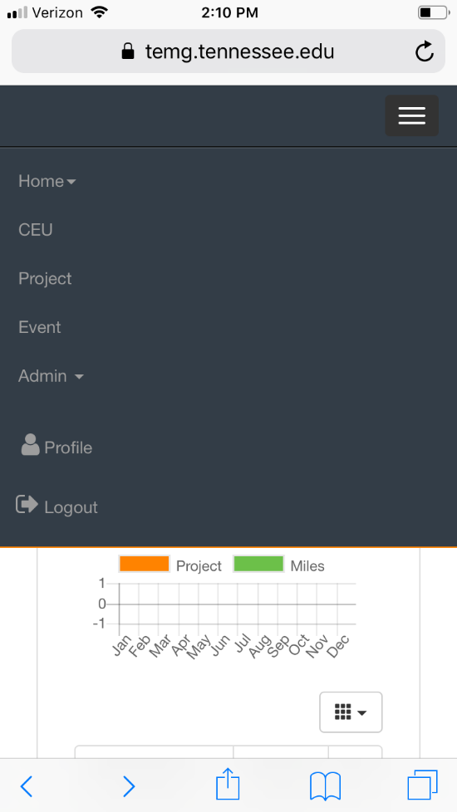

These options will appear (5).
5.

Home, CEU, Project, Profile, Logout
At any time while on the site you may go to this
Drop down and select another area to work in.

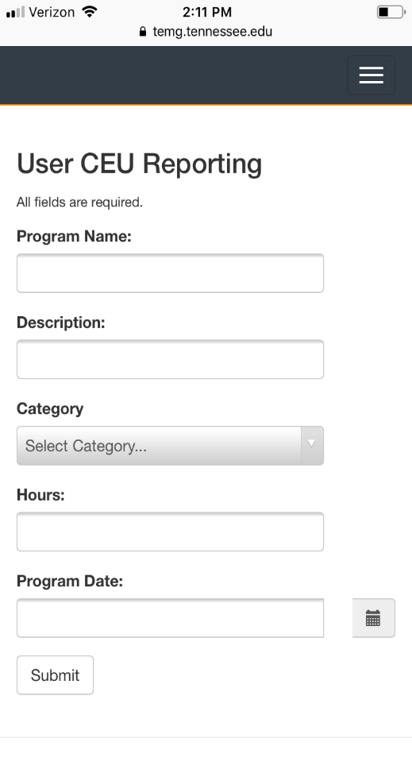
Reporting Continued Education:
7.
Select CEU from drop down menu
Select Log CEU Hours Icon (6).
Enter Program Name, Description (7)
Category, Hours, & Date.
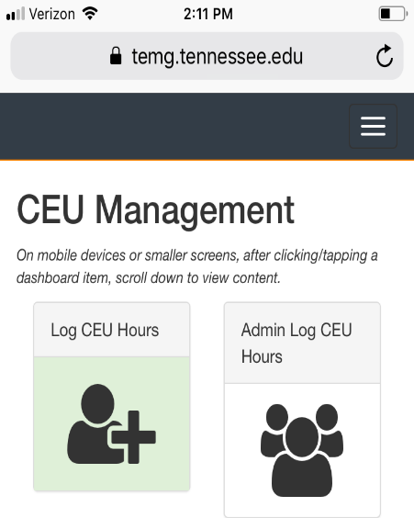
Click Submit.
6.

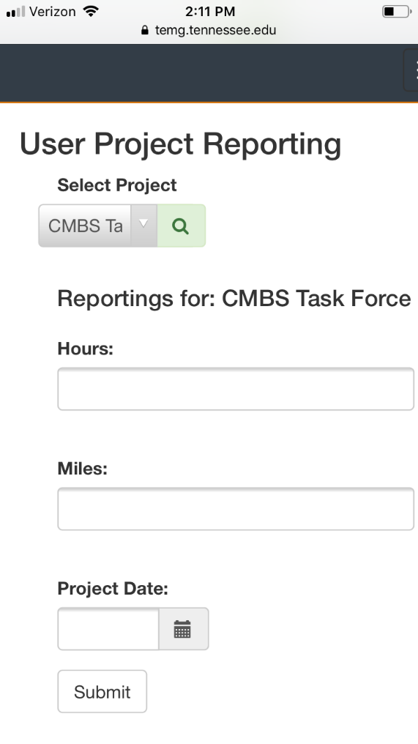
Reporting Projects:
9.
Select Project from drop menu.
Select Log Project Hours (8).
Pick Project from drop down list (9).
Click Green magnifying glass.
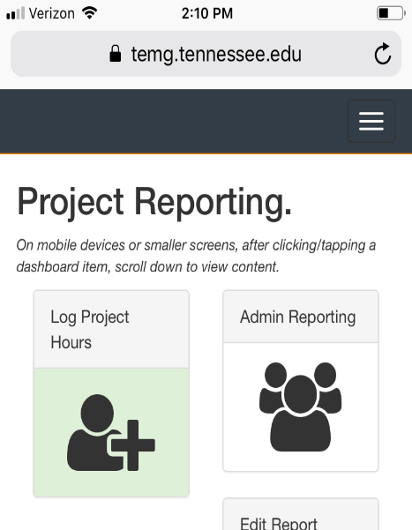
Enter Hours and Miles traveled.
Enter Project Date.
Click Submit.
8.

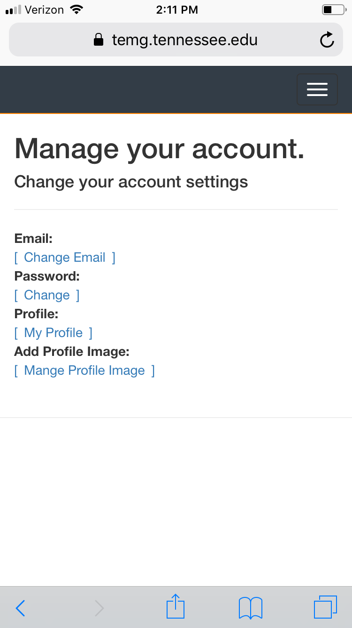
10.

Update Profile:
Select Profile from drown down menu.
From here you can change
Email, Password, Profile Information,
And add a picture!! (10)

