Vegetable Gardeners ToolShed Series 2018

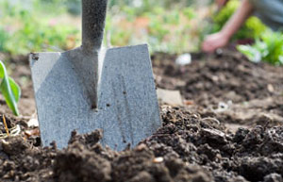
These classes are FREE to the community and we encourage you to bring a friend! Classes held at Ag Complex Auditorium 309 North Parkway Jackson, TN 38305
Call ahead to register and for more information:
Celeste Scott 731-668-8543 or cscott52@utk.edu

February 20th 5:30-6:30 pm Where to Begin
Site Selection & Garden Planning

March 20th 5:30-6:30 pm Don’t Dig Dirt, Shovel Soil!
Understanding Soil & Plant Nutrition

April 3rd 5:30-6:30 pm Planting Basics
Cool vs. Warm Season Crops & Transplants vs. Seed

May 8th 5:30-6:30 pm Composting
Benefits & Easy How to

May 22nd 5:30-6:30pm Garden Maintenance
Irrigation, Mulch, & Weed Prevention

June 5th 5:30-6:30 Disease
Common Problems & Preventative Practices

June 19th 5:30-6:30 pm Pest
Tools for ID & Control

July 10th 5:30-6:30 pm Preparing for Fall
Season Extension, Cleaning & Cover Cropping

